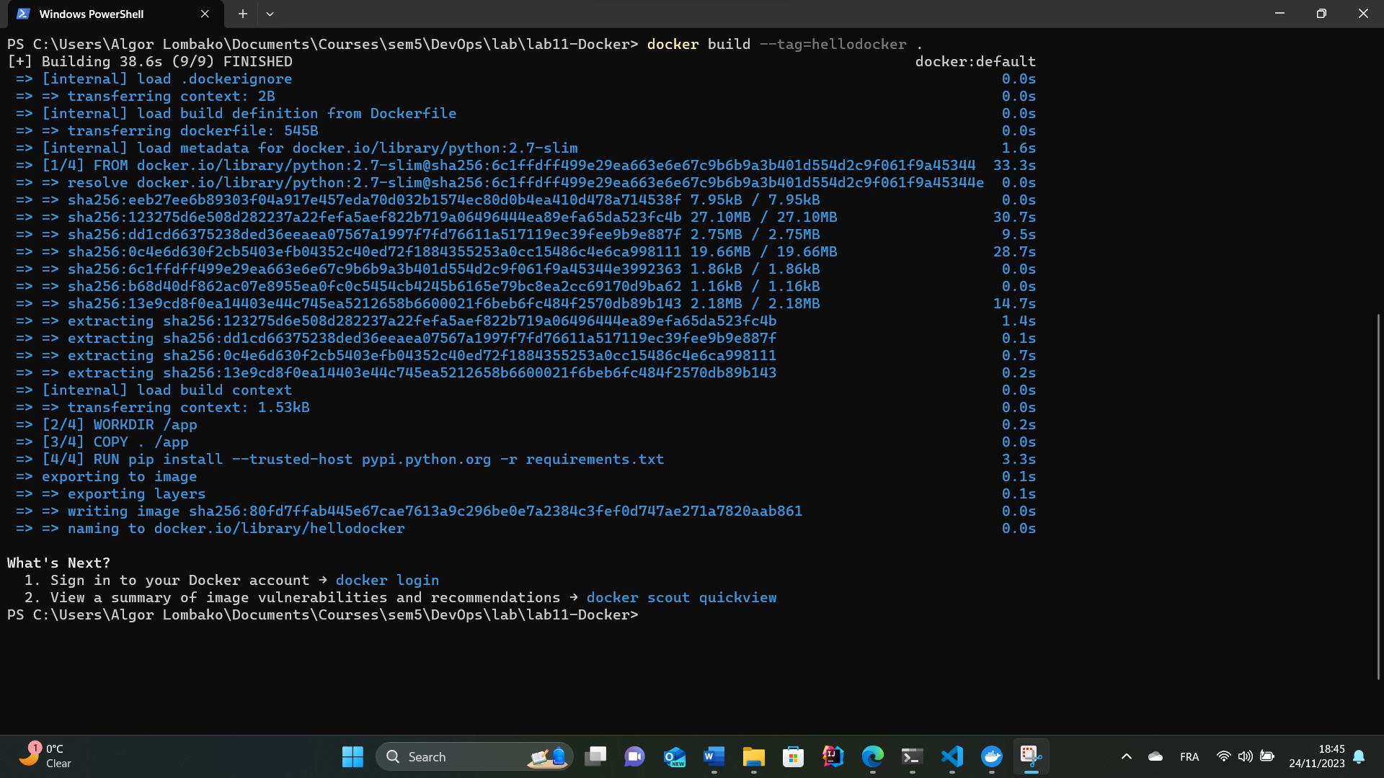

Dockerfile execution

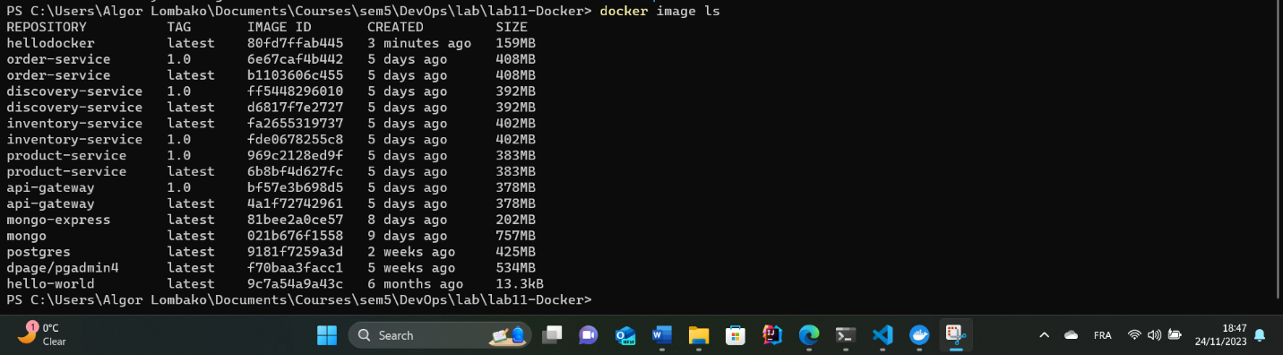

Image list



Stop container

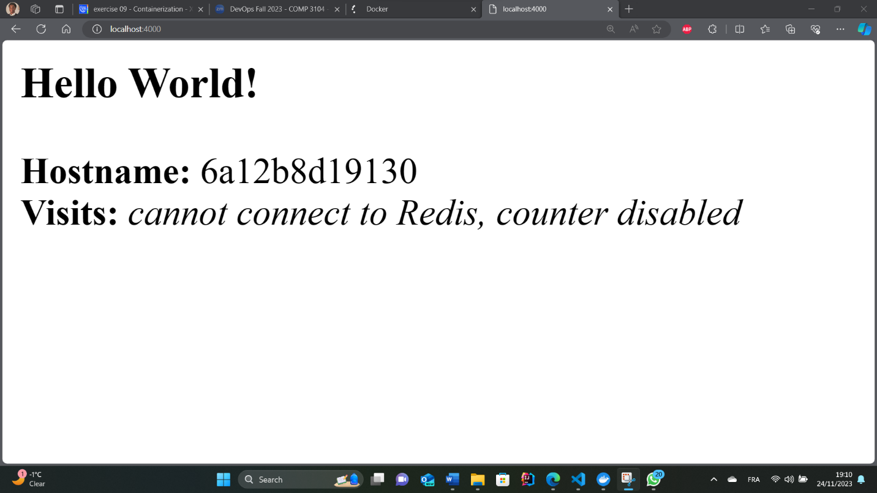

Localhost page

Run container on port 4000